Week 7 Lab Instructions
FFT Calculations and Oscilloscope FFT Intro

Course Number: ECET430
Name:
Laboratory Number: 6 (Week 7)
Laboratory Title: FFT Calculations and Oscilloscope FFT Math Function
Submittal Date: Click here to enter a date.
Instructions: Using this document as your template, follow the steps, answer the questions, and insert your screen shots as you progress through the lab.

Lab Overview

This lab has been designed to help you gain proficiency in making FFT calculations and give you practice in utilizing your oscilloscope for Fast Fourier Transforms. A Fourier Transform of a signal tells you what frequencies are present in your signal and in what proportions and has widespread importance in signal processing.

Required Materials

To accomplish this lab, you will need the following equipment

- One oscilloscope with an FFT math function on it.
- Oscilloscope probes
- One signal generator

Lab Procedure
- Sine Wave
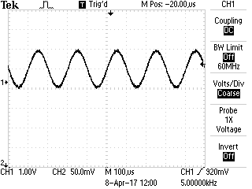
Time for one cycle _______________; Frequency _______________
Peak to Peak Amplitude __________; DC Value _______________
The origin is 0 volts DC.
Calculate the Frequency Spectrum (don’t forget the DC component) and show your results below (refer to our lesson on Fast Fourier Transforms).

Replicate the waveform on your Oscilloscope using the Math Function FFT and copy the screenshot below.

- Saw tooth Waveform
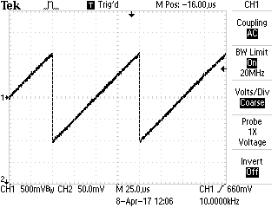
Time for one cycle _______________; Frequency _______________
Peak to Peak Amplitude __________;

Calculate the Frequency Spectrum and show your results below.

Replicate the waveform on your Oscilloscope using the Math Function FFT and copy the screenshot below.

- Square Wave
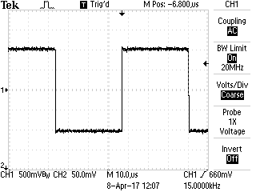
Time for one cycle _______________; Frequency _______________
Peak to Peak Amplitude __________;

Calculate the Frequency Spectrum and show your results below.

Replicate the waveform on your Oscilloscope using the Math Function FFT and copy the screenshot below.

- Pulse Waveform or Unsymmetrical Square Wave
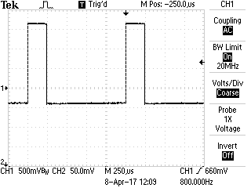
Time for one cycle _______________; Frequency _______________
Peak to Peak Amplitude __________;

Calculate the Frequency Spectrum and show your results below.

Replicate the waveform on your Oscilloscope using the Math Function FFT and copy the screenshot below.

- Pulse waveform;
1v for 0-1 usec
0v for 1.001-100 usec, then it repeats

Calculate the frequency spectrum as close as you can out to the third null and show your results below:

Conclusion: After making FFT calculations for various waveforms, what is the value of being able to calculate FFTs and perform FFT measurements on your Oscilloscope in relation to what you have learned about DSP? Which number waveform is closest to the impulse function?

